<Talk Box>

User Manual
Version 1.0
02/04/2019
Group Number: <EECS2311 Group #1>

Table of Contents
1. Introduction 1
2. Overview 2
2.1 Conventions 2
2.2 Cautions & Warnings 2
3. Getting Started 3
3.1 Set-up Considerations 3
3.2 User Access Considerations 3
3.3 Accessing the System 3
3.4 System Organization & Navigation 3
3.5 Exiting the System 3
4. Troubleshooting & Support 5
4.1 Error Messages 5
4.2 Support 5
Appendix A: Record of Changes 6

List of Figures
No table of figures entries found.

List of Tables
Table 1 - Support Points of Contact 5
Table 2 - Record of Changes 6

Introduction
This program is a raspberry pi simulation of the Talk-Box Application which will help the disabled get their thoughts through. The Talk-Box has different number of has a number of buttons depending on the set the user is on. The buttons can play anything the user sets it to be, it can play a word, a sound, a phrase anything they like. All they have to do is open the Talk-Box-Configurator and edit the buttons their images and their audio files. The preferred extension for audio file is .wav and the images are .jpg. The buttons will play sound once it has clicked/tapped.

The application is very simple and user intuitive which helps in for an average person with no prior programming or technical knowledge to configure the buttons for their own. The means Installation is simple. You will need a list of few things mentioned below:
- Java 8 or above
- JRE
- Have the TalkBoxData folder inside the same folder as the TalkBoxSimulator and TalkBoxConfigurator
Once installing the named components all you have to do is run the jar file and it will open a window. Once the window has been opened the basic functionality is just opening the particular set of buttons, and then clicking the respective buttons for audio to be played. To configure the Talk-Box buttons, all you have to do is close the simulator, then open the configurator from the very same folder and then edit the buttons, add buttons etc. The screenshots for the simulator, and configurator as here:

Overview
Instructions: Navigate to the folder you have downloaded all three components of the application (Simulator, TalkBoxData Folder, and Configurator). Once there you can simple click the Simulator java application and it will run the simulator, where the user can open and use the buttons to play audio from different audio sets. To configure the buttons, one has to simply close the Simulator and then open the Configurator java app, which will then give them choices to edit the buttons, and add them if necessary. An overview of the application is as such:
- Key features or major functions performed by the by the Talk-Box:
  - Different number of buttons categorized based on genre.
  - Can have as many buttons as required by the user in each set.
  - The prototype only has 2 sets of buttons, but in future additions, can be changed and have multiple set of buttons.
- Java Based Application. Requires Java 8 and JRE.
- Graphical User Interface, with clickable buttons and innovative looks.
- System specification: Can have any OS as it is a multi-Support Application that can run on any OS – Windows, Mac, Ubuntu, Linux Based.

Conventions
When an action is required on the part of the reader, it is indicated by a line beginning with the word “Action:” For example:
Action: Click on OK.
Fields or buttons to be acted upon are indicated in bold italics in the Action statement; links to be acted upon are indicated as links in underlined blue text in the Action statement.
Note: The term ‘user’ is used throughout this document to refer to a person who requires and/or has acquired access to the <Talk Box>.

Cautions & Warnings
Instructions: There are a list of measures to take before running the Talk Box. As of now, the User has to manually copy the TalkBoxData folder to the current directory that has the TalkBotSimulator.jar and TalkBotConfigurator.jar files. The user has to also ensure, they are running the latest and updated version of Java and JRE in their System. The real Talk Box might look different than the manual due to System features.

Getting Started
Instructions: How to get the Talk Box and how to get everything working and Running.

Set-up Considerations
Instructions: The User has to initially go to https://github.com/Eli-Fr/EECS2311 . And download These particular files/Folder from the folder vM :
- TalkBoxSimulator.jar
- TalkBoxConfigurator.jar
- TalkBoxData(Folder)
TalkBoxSimulator screens are designed to be viewed at a minimum screen resolution of 1280 x 720p. To optimize your access to the <Talk Box>:
- Please use Java 8 or above.
- Ensure your system’s resolution is minimum of 1280 x 720p.

User Access Considerations
Instructions: The User that wants to use the TalkBox should open the TalkBoxSimulator to use it for playing audio out of the buttons. However, the TalkBoxConfigurator should only be opened by one with authorization aka Parent, Guardian or Responsible Adult.

Accessing the System
Instructions: The System can be accessed by a simple Double Click on the respective Icon. 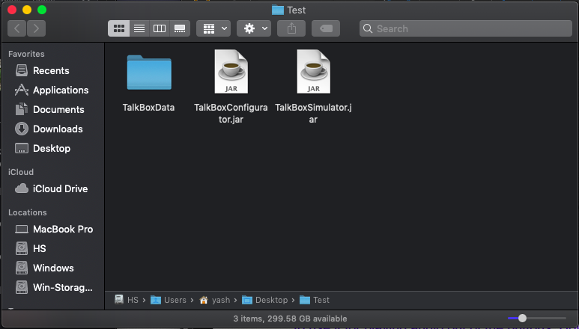
Another way to open the file is by using Terminal or CMD(For Windows) although this is not recommended for average Users. However an advanced User shall use this mehtod as well. First move to the respective directory using cd FolderName; Then Type the following Command to Start.
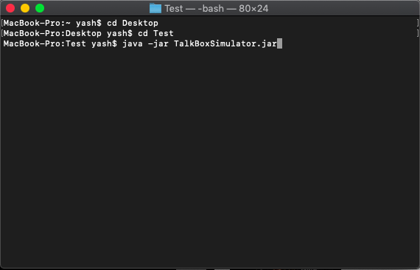

System Organization & Navigation
Instructions: The way to navigate around the App is really Simple.
TalkBoxSimulator:

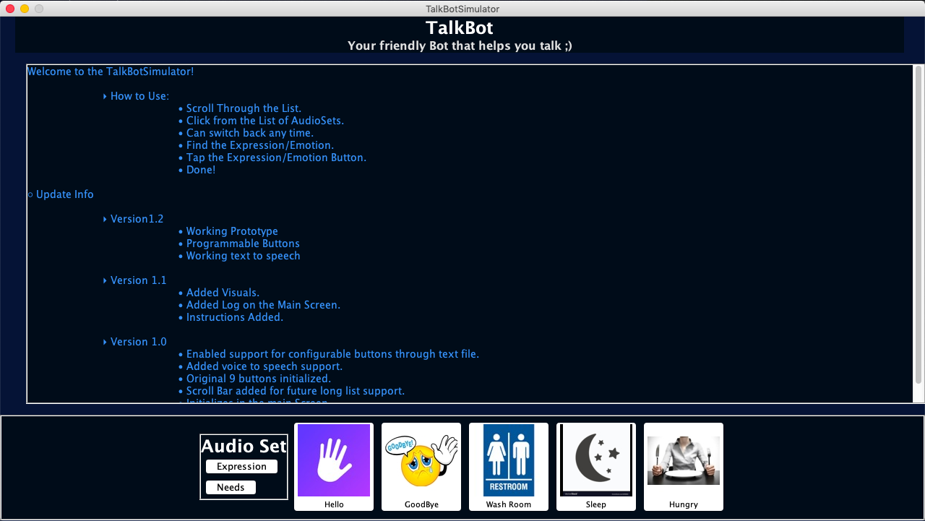
- Click one of the Respective(Ticked in Red) Buttons to play the Audio.
- Click the one of the Audio Set buttons to switch between sets.
TalkBoxConfigurator: 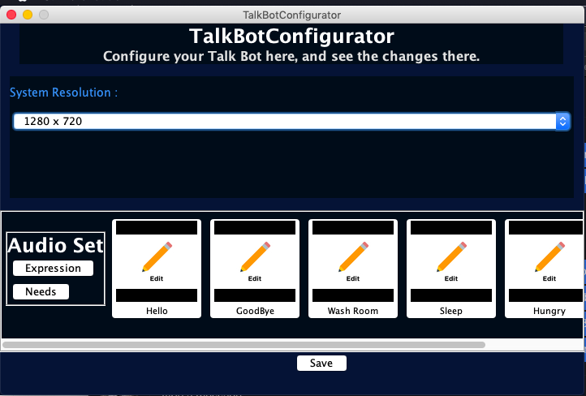
- This is how the Configurator Looks.
- Choose one form the List of Resolutions. Default is set to 1280 x 720p
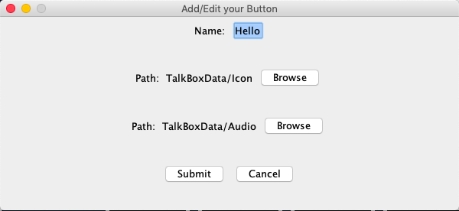
- Once you click the button, This menu will pop up where you can change the name, the image, the Audio.


- Click this Button to Add a new button to the set.
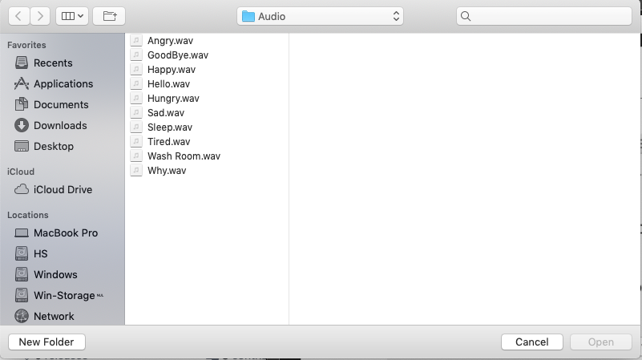
- This is how the Browse Menu Looks, (It might look different depending on the OS).

Exiting the System
Instructions: To Exit either of the Apps, you can click on the X Icon on the status Bar which will be on the Right or Left corner of the Window depending on the OS.

Troubleshooting & Support
Instructions: Troubleshooting and Support can be achieved for the Product by sending a Private Message to us on the Moodle Page. And we can help you. To Further help us, you can run the program thorught the terminal/CMD method shown above to give us a detailed description of the Error.

Error Messages
Instructions: Once Run through the Terminal/CMD the Error that Typically Crashes/Freezes the App can be shown in a way.
Note: Pop-Ups aren’t Errors as they are for your information, unless the popup talks about Exiting.

Support
Instructions: Provide information on how the user can get emergency assistance and system support (e.g., help desk support, production support, etc.). Include the names of the responsible personnel and organization(s), telephone numbers, and email addresses of the staff who serve as points of contact for system support. The following table is provided as an example and may be modified as needed. Also provide instructions for how identified problems with the system are to be reported. Include instructions for security incident handling, as appropriate.
Table 1 - Support Points of Contact
Contact | Organization | Phone | Email | Role | Responsibility
<Yash Desai> | <York University> | <Phone> | <Email> | <Developer> | <Support/Develop>
<Eli Frungorts> | <York University> | <Phone> | <Email> | <Developer> | <Support/Develop>
<Kai Xu > | <York University> | <Phone> | <Email> | <Developer> | <Support/Develop>

Appendix A: Record of Changes
Instructions: Provide information on how the development and distribution of the User Manual will be controlled and tracked. Use the table below to provide the version number, the date of the version, the author/owner of the version, and a brief description of the reason for creating the revised version.
Table 2 - Record of Changes
Version Number | Date | Author/Owner | Description of Change
<1.0> | <02/24/2019> | EECS 2031 Group #1 | <Working/Mid-term Prototype>

